Name: Taniya Asif
Std ID: BIT-24S-0014
GitHub Link: https://github.com/taniyasif/Python-labs/upload/main

Lab 08
Task 1: Make a calculator using the function the code should use only 2 operands(+ and -) for division and multiplication as well.
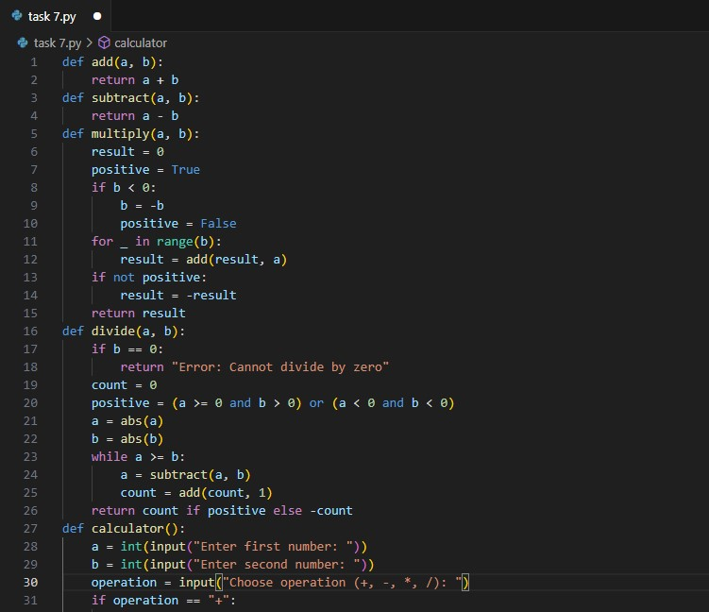
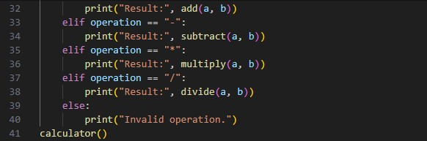

Output
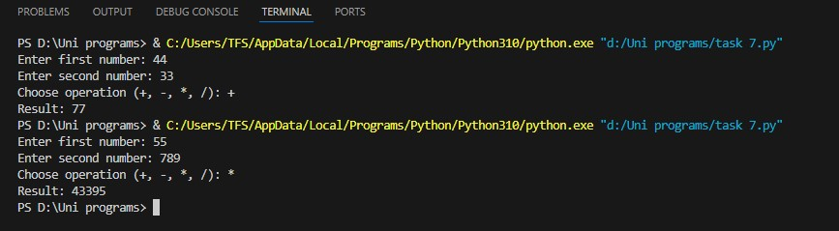
Task 2: Write a functions that ask the user the shape and make the star shaped.
(Like it asks the shape(triangle or Rectangle) and make that shape.
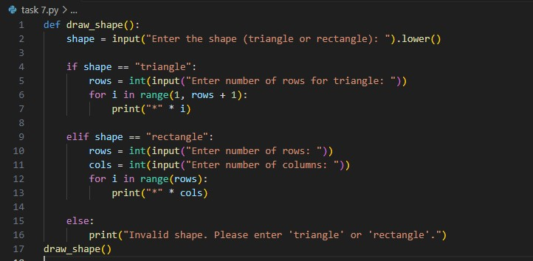

Output
